
NAME: AMIRDHA A
REG NO: 192324072

Mobile Computing LAB
- Design a wireframe for a mobile application that incorporates security measures using Figma

Aim:

To design a mobile application wireframe in Figma that incorporates security measures such as login authentication, password protection, and secure access.

Procedure:

- Open Figma and create a new design file.

- Create a mobile screen using a frame.

- Design a login page with username and password fields.

- Add a login button, password visibility option, and forgot password link.

- Design an OTP verification screen for two-factor authentication.

- Connect the screens using prototype interactions.

- Preview the design.

Design:
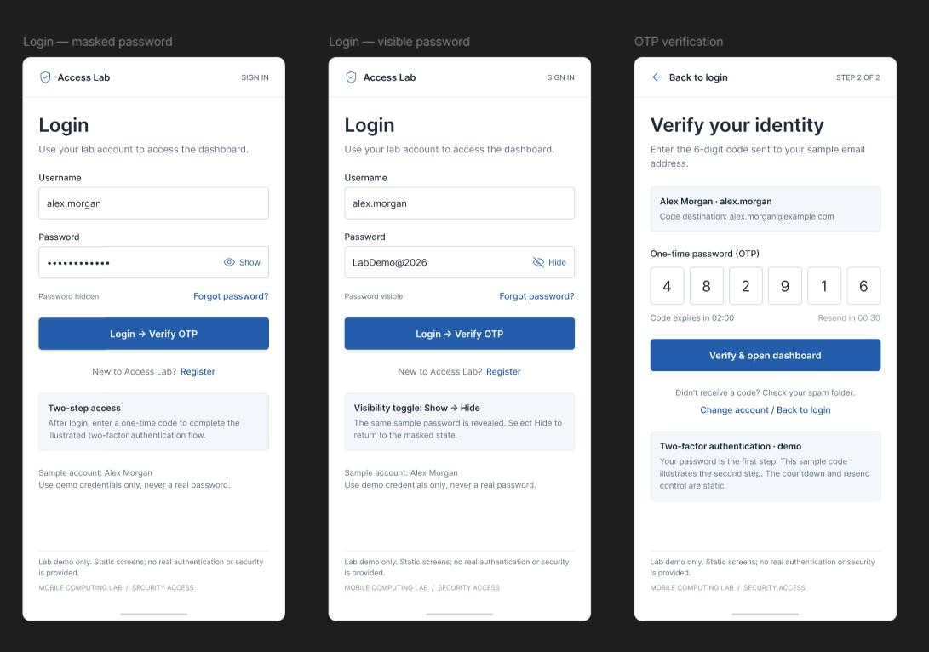

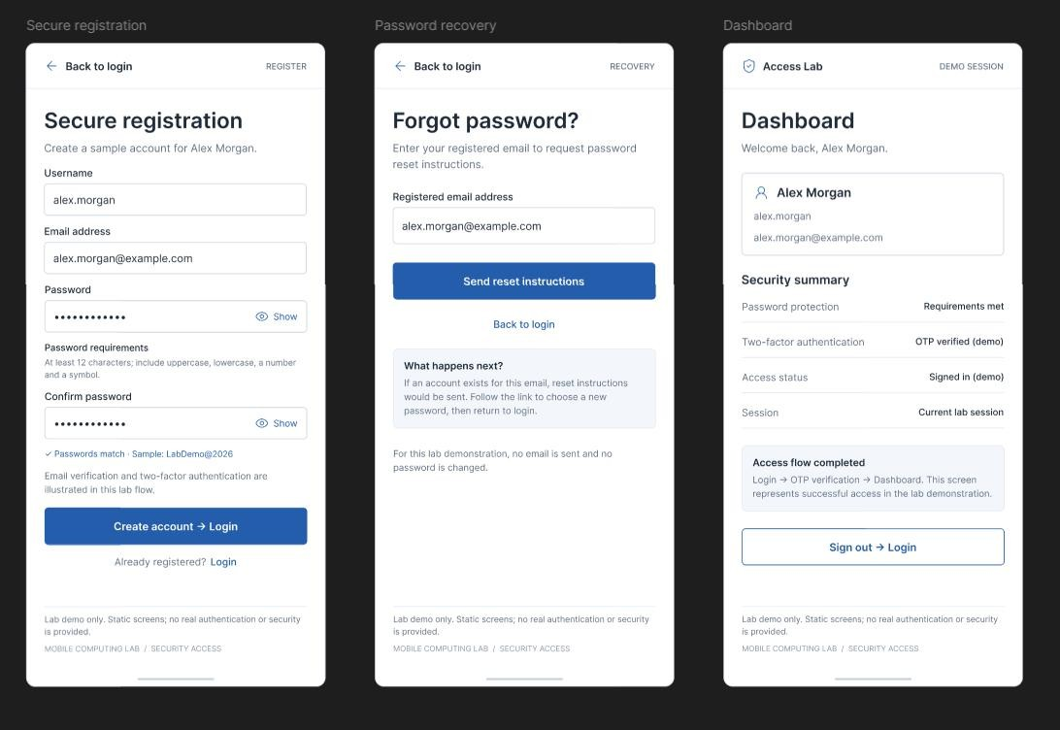

Result:

A secure mobile application wireframe was successfully designed using Figma.

Use Figma to Create an Interactive Diagram Illustrating the Evolution from 1G to 5G

Aim:

To create an interactive Figma diagram illustrating the evolution of mobile communication technologies from 1G to 5G.

Procedure:

- Open Figma and create a new design file.

- Create five frames representing 1G, 2G, 3G, 4G, and 5G.

- Add the technology name, features, and data speed for each generation.

- Arrange the frames in chronological order.

- Add arrows connecting each generation.

- Use prototype connections to make the diagram interactive.

- Preview the diagram.

Design:
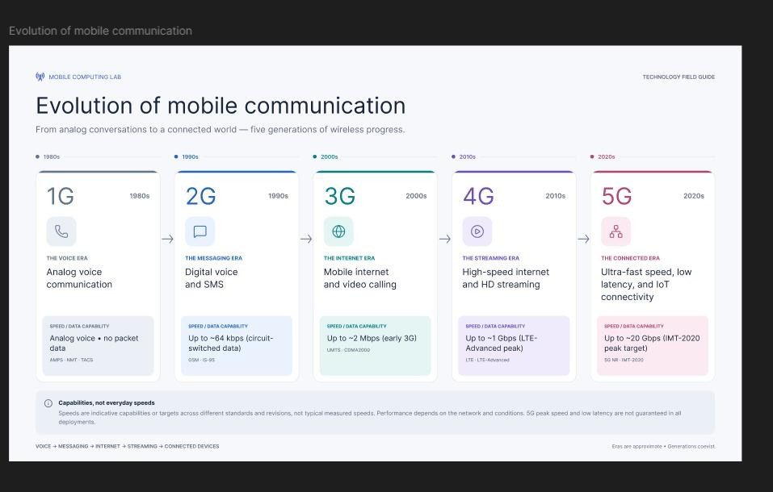

Result:

An interactive diagram illustrating the evolution of mobile communication from 1G to 5G was successfully created in Figma.

Design an Infographic in Figma Comparing Mobile Communication and Mobile Computing

Aim:

To design an infographic in Figma comparing mobile communication and mobile computing based on their features and applications.

Procedure:

- Open Figma and create a new design file.

- Create an infographic frame.

- Divide the frame into two sections.

- Add mobile communication features such as wireless transmission, networks, and connectivity.

- Add mobile computing features such as data processing, applications, and portability.

- Include suitable icons, colors, and illustrations.

- Arrange the content neatly and preview the design.

Design:
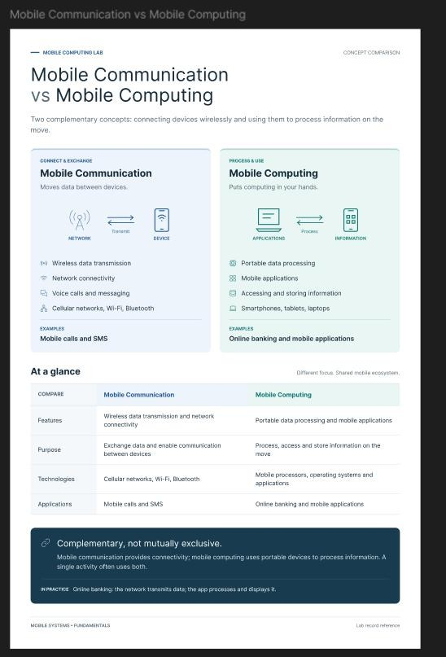

Result:

An infographic comparing mobile communication and mobile computing was successfully designed using Figma.

Develop a Flowchart in Figma Explaining the Operation of GPRS Aim:

To develop a flowchart in Figma explaining the operation of General Packet Radio Service (GPRS).

Procedure:

- Open Figma and create a new design file.

- Create a flowchart using standard symbols.

- Add the following steps:

  - Mobile Station (MS)
  - Base Station Subsystem (BSS)
  - Serving GPRS Support Node (SGSN)
  - Gateway GPRS Support Node (GGSN)
  - Internet

- Connect the components using arrows.

- Add labels explaining packet transmission.

- Arrange the flowchart clearly.

- Preview the final design.

Design:
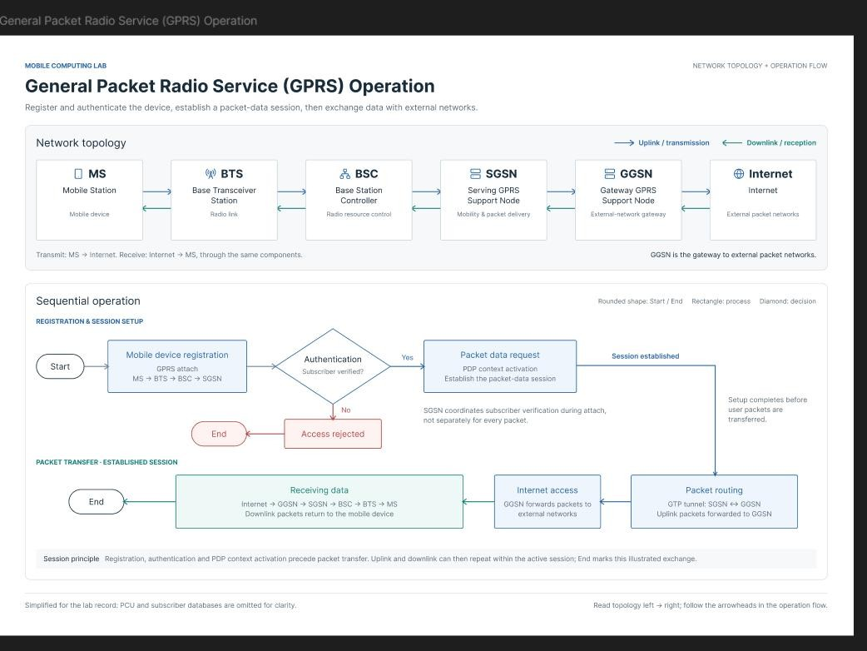

Result:

A flowchart explaining the operation of GPRS packet transmission was successfully developed using Figma.

Develop a Wireframe for a Mobile Application Addressing Challenges Related to Ad Hoc Wireless Networks Using Figma

Aim:

To design a mobile application wireframe in Figma that addresses challenges in ad hoc wireless networks, such as node connectivity, routing, and network reliability.

Procedure:

- Open Figma and create a new design file.
- Create a mobile application frame.
- Design a home screen displaying network status.
- Add screens for node discovery, routing information, and connection status.
- Include features for monitoring signal strength and identifying disconnected nodes.
- Add buttons for reconnecting nodes and troubleshooting network issues.
- Connect the screens using prototype interactions.
- Preview the wireframe.

Design:
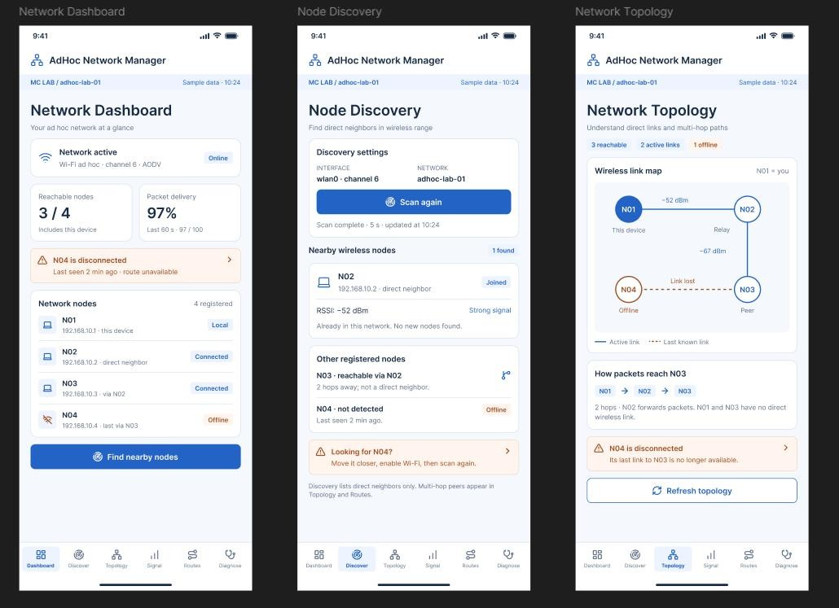

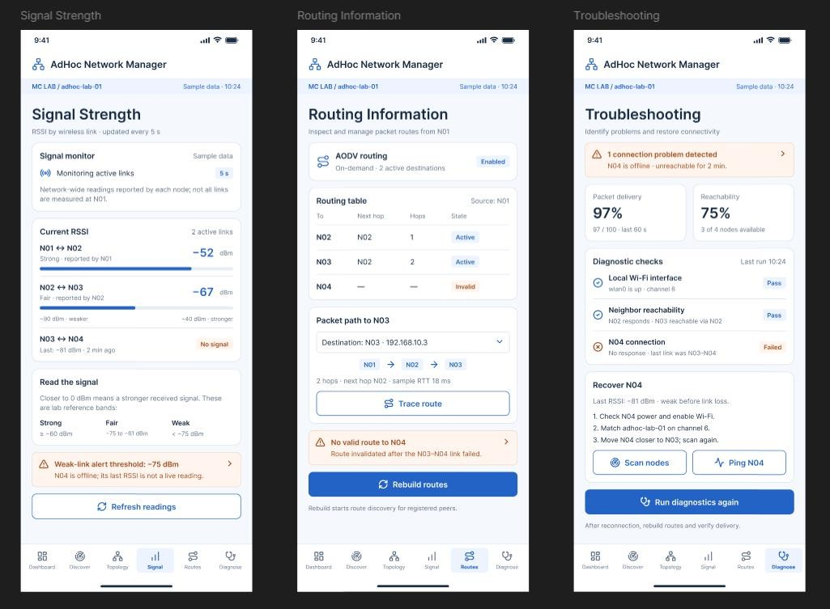

Result:

A mobile application wireframe addressing ad hoc wireless network challenges was successfully designed using Figma.

Design a Dashboard Displaying Network Performance Metrics Aim:
To design a dashboard displaying network performance metrics such as signal strength, bandwidth, latency, and packet loss.

Procedure:

- Open Figma and create a new design file.
- Create a dashboard frame.
- Add metric cards for signal strength, bandwidth, latency, and packet loss.
- Include graphs to represent network performance.
- Add network status indicators.
- Arrange the components using proper alignment and spacing.
- Preview the dashboard.

Design:

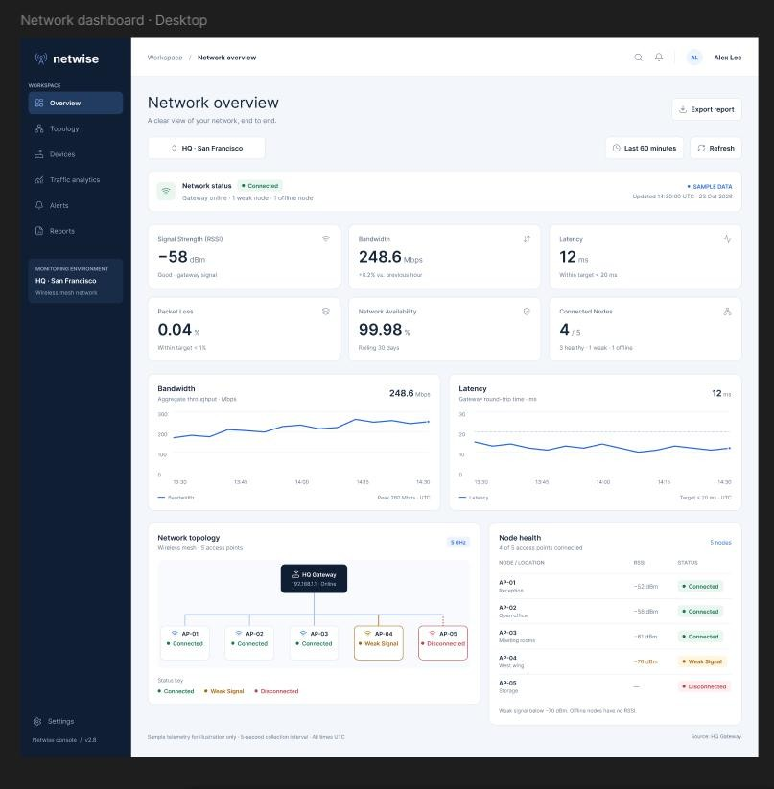
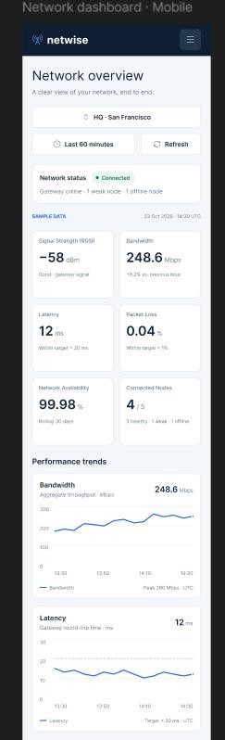
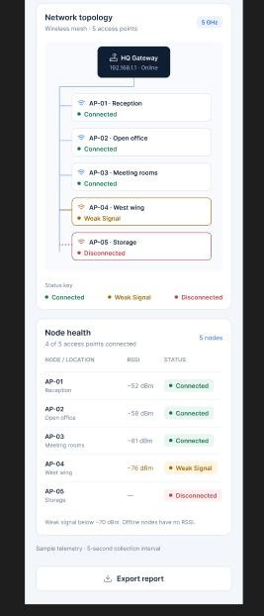

Result:

A network performance dashboard displaying important network metrics was successfully designed using Figma.

Create an Error Alert UI for Connection Drops Aim:
To create an error alert user interface in Figma for notifying users about network connection drops.

Procedure:

- Open Figma and create a new design file.
- Create a mobile application frame.
- Design an error alert box.
- Add a warning icon and the message "Connection Lost".
- Include buttons such as "Retry" and "Network Settings".
- Use suitable colors and typography to highlight the error.
- Create prototype interactions for the buttons.
- Preview the alert UI.

Design:
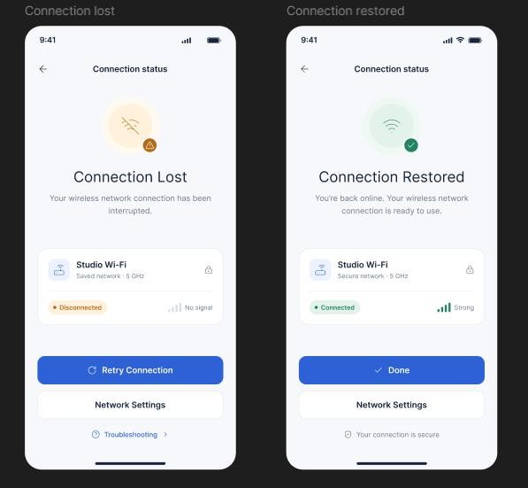

Result:

An error alert UI for connection drops was successfully created using Figma.

Simulate a Basic Ad Hoc Network Using a Networking Tool Aim:
To simulate a basic ad hoc wireless network using a networking simulation tool.

Procedure:

- Open a networking simulation tool such as NS-2 or NS-3.
- Create multiple wireless nodes.
- Configure the wireless channel and network interface.
- Set up an ad hoc routing protocol such as AODV.
- Establish communication between the nodes.
- Generate traffic between source and destination nodes.
- Run the simulation and observe packet transmission.

Design:
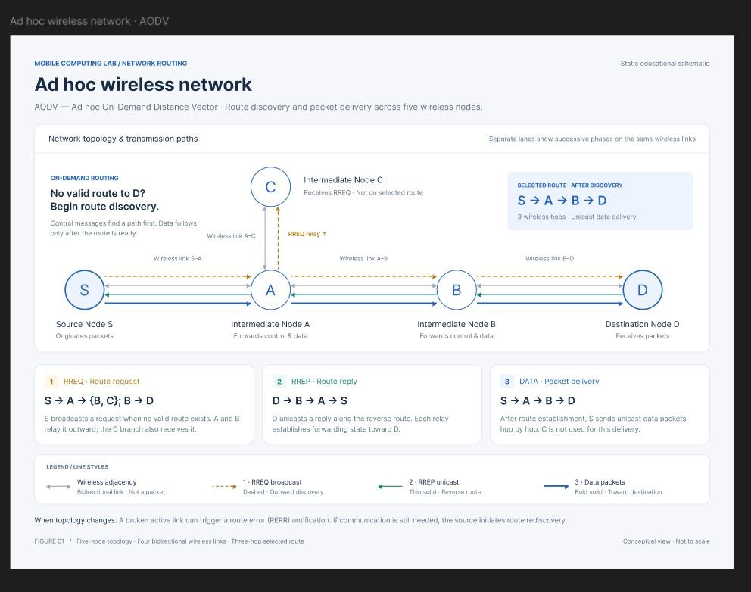

Result:

A basic ad hoc wireless network was successfully simulated using a networking tool.

Analyze Signal Strength Between Nodes in a Simulated Environment Aim:
To analyze the signal strength between wireless nodes in a simulated ad hoc network environment.

Procedure:

- Open a networking simulation tool.
- Create multiple wireless nodes.
- Configure transmission power and communication range.
- Establish communication between the nodes.
- Vary the distance between the nodes.
- Observe the received signal strength (RSSI).
- Record and compare the signal strength values.

Design:
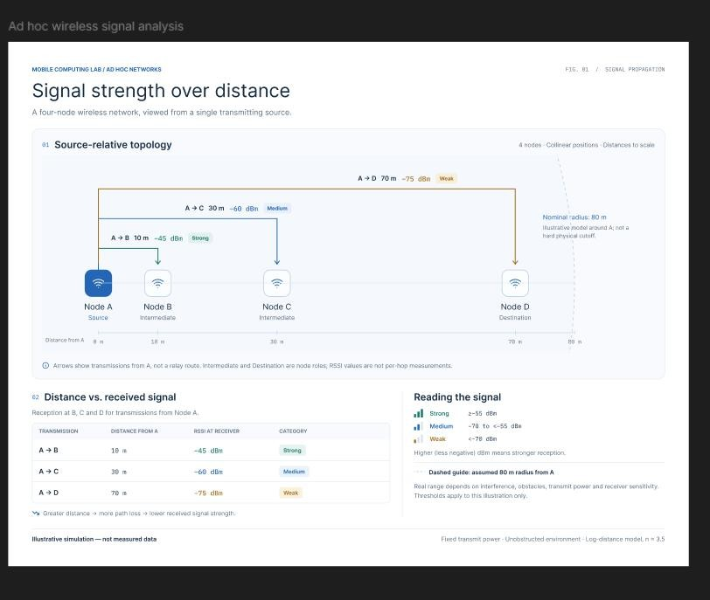

Result:

The signal strength between wireless nodes was successfully analyzed in a simulated environment.

Develop a Troubleshooting Flow for Common Issues in Ad Hoc Networks Aim:
To develop a troubleshooting flowchart for identifying and resolving common issues in ad hoc wireless networks.

Procedure:

- Open Figma and create a new design file.

- Create a flowchart frame.

- Add the starting point as "Network Problem Detected".

- Add decision blocks for checking node connectivity, signal strength, routing, and packet loss.

- Add corrective actions such as reconnecting nodes and updating routing information.

- Connect the blocks using arrows.

- Add the final step as "Network Restored".

- Preview the flowchart.

Design:
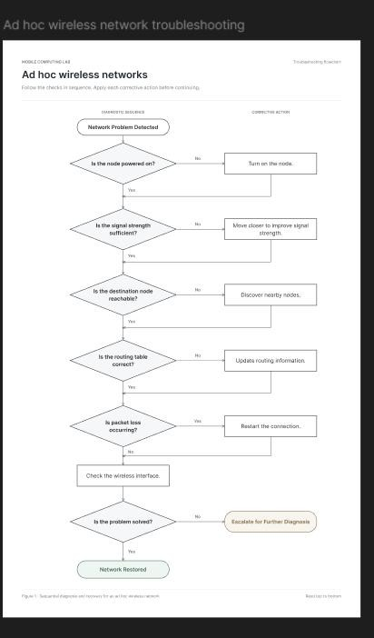

Result:

A troubleshooting flowchart for resolving common ad hoc wireless network issues was successfully developed using Figma.

